**Some Instructions/Guidelines**

1. Develop a simple frontend application.

2. Write simple enough code which is easy to understand.

3. Avoid writing too many lines of production code.

4. Include test cases.

5. Include all the dependencies with your solution so that we can open it easily in IDE and review/execute it with minimal efforts :)

6. Please do not attach the **node_modules**folder. Sending project directory excluding **node_modules**is more than enough.

1. Bind All Dropdown Data Given Below Api.
2. When user submit detail,it shown in table (store data in local storage)
3. When delete remove entire row
4. When click on edit that row details fill the information in form & submit button label will be Update
5. same component form & table

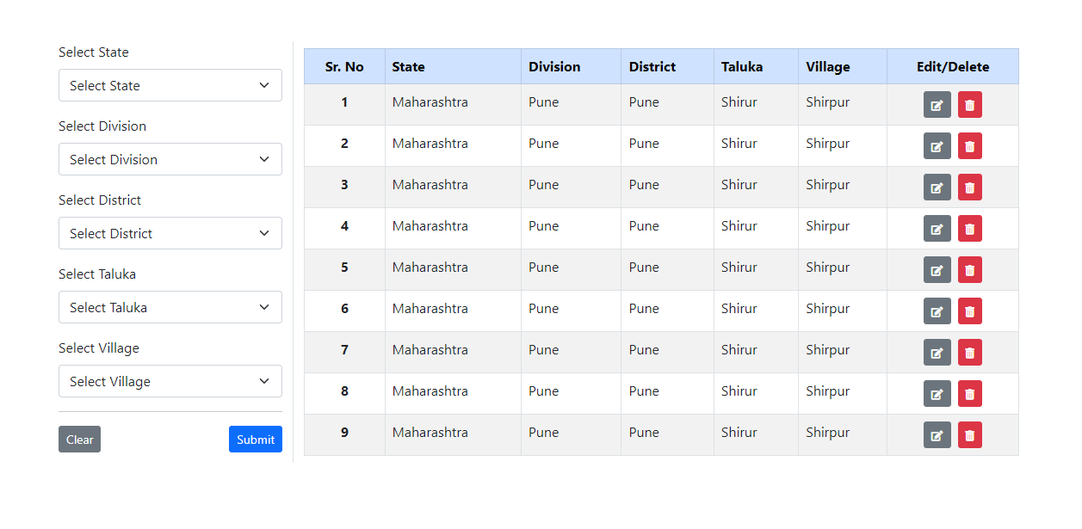

1. State Api = <http://awsmaster.mahamining.com/master/states/GetState> (Select Maharashtra State)

2. Divisions Api = http://awsmaster.mahamining.com/master/divisions/id

3. District Api = http://awsmaster.mahamining.com/master/districts/GetDistrictByDivisionId?UserId=1&DivisionId=id

4. Taluka Api =

<http://awsmaster.mahamining.com/master/talukas/GetTalukaByDistrictId/id>

5. Village Api =

http://awsmaster.mahamining.com/master/villages/GetVillagesByCriteria/id